1) Write a Java program to get the character at the given index within the String

Program:

package com.string;

public class ChangeSpecificWord {

public static void main(String[] args) {

String str = "LICET college";

String input = "raju";

String res = str.replaceAll(input, input.toUpperCase());

System.***out***.println(res);

}

}

Output:

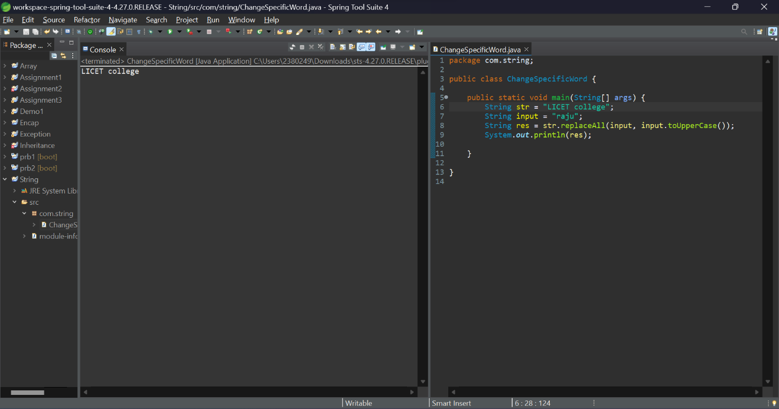

2) Write a Java program to convert all the words first letter into capital for given String? (String s=”java standard edition”)

Program:

package com.string;

public class ConvertToUpperCase {

public static void main(String[] args) {

String str = "licet college";

int n = str.length();

int count = 0;

String newline="";

for(int i=0;i<n;i++)

{

if(str.charAt(i)=='l')

{

count++;

if(count==2)

{

if(str.charAt(i)>=97 && str.charAt(i)<=123)

{

int a=(int)str.charAt(i);

a=a-32;

newline+=(char)a;

}

else {

newline+=str.charAt(i);

}

}

else {

newline+=str.charAt(i);

}

}

else {

newline+=str.charAt(i);

}

}

System.***out***.println(newline);

}

}

Output:

3) Write a Java program to test if a given string contains the specified sequence of char values….match()

“welcome to carrertuner”

Program:

package com.string;

import java.util.Scanner;

public class EndsWith_Function {

public static void main(String[] args) {

Scanner sc=new Scanner(System.***in***);

System.***out***.println("Enter your String: ");

String sentence=sc.nextLine();

System.***out***.println("Enter your String to find the its get finished by above string: ");

String sentence1=sc.nextLine();

if(sentence.endsWith(sentence1))

{

System.***out***.println("Yes, The string "+sentence+" is ends with "+sentence1);

}

else {

System.***out***.println("No, The string "+sentence+" is not ends with "+sentence1);

}

}

}

Output:

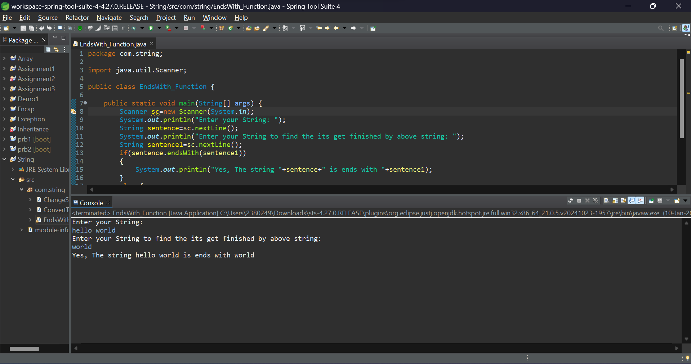

4) Write a Java program to check whether a given string ends with the contents of another string (endsWith())

Program:

package com.string;

import java.util.Scanner;

public class Capital_Letter {

public static void main(String[] args) {

Scanner sc=new Scanner(System.***in***);

System.***out***.println("Enter your String: ");

String sentence=sc.nextLine();

System.***out***.println("The Capital Letterin the string are: ");

for(int i=0;i<sentence.length();i++)

{

if(sentence.charAt(i)>=65 && sentence.charAt(i)<=91)

{

System.***out***.println(sentence.charAt(i));

}

}

}

}

Output:

5) Count the number of words present in the given string?

Program:

package com.string;

import java.util.Scanner;

public class Count_Length {

public static void main(String[] args) {

Scanner sc=new Scanner(System.***in***);

System.***out***.println("Enter your String: ");

String sentence=sc.nextLine();

String[] str=sentence.split(" ");

System.***out***.println("The Number of Words Present in the Sentence is: "+str.length);

}

}

Output:

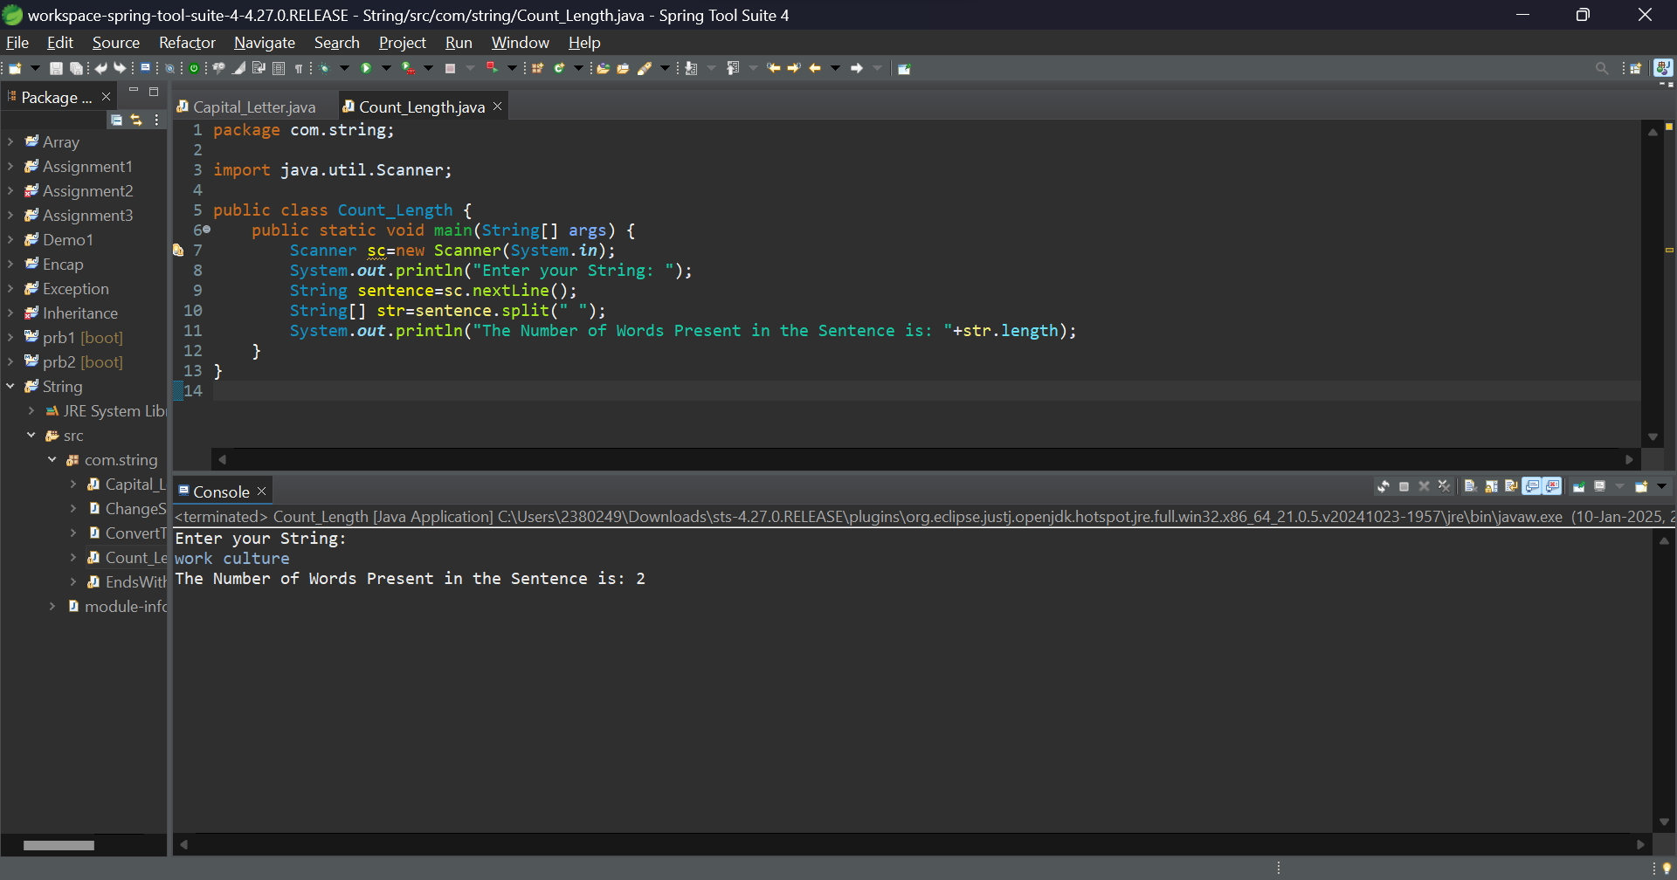

6) Print the capital letters from string?

Program:

package com.string;

import java.util.Scanner;

public class Match_Word {

public static void main(String[] args) {

Scanner sc=new Scanner(System.***in***);

System.***out***.println("Enter your String1: ");

String sentence1=sc.nextLine();

System.***out***.println("Enter your String2: ");

String sentence2=sc.nextLine();

System.***out***.println("Enter your String3: ");

String sentence3=sc.nextLine();

System.***out***.println("Enter the Word to find it:");

String sentence=sc.nextLine();

if(sentence.matches(sentence1) || sentence.matches(sentence2) || sentence.matches(sentence3))

{

System.***out***.println("The word "+sentence+" is found");

}

else {

System.***out***.println("The word "+sentence+" is not found");

}

}

}

Output:

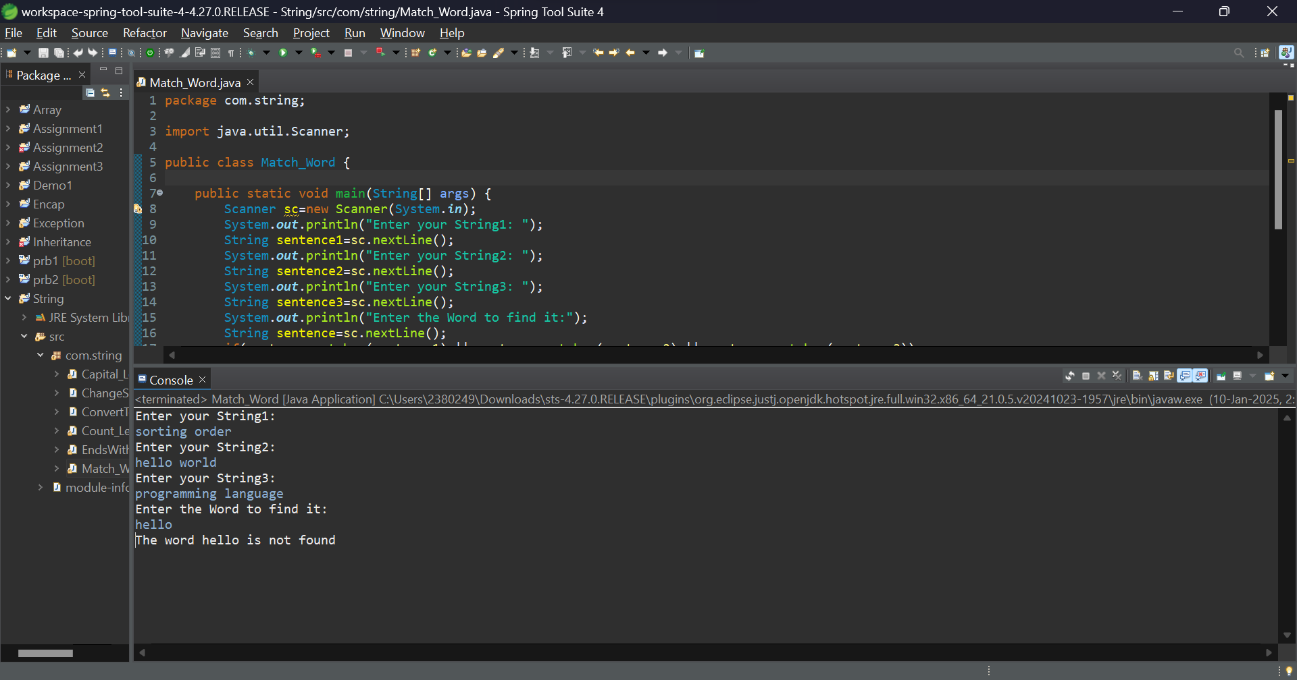

7) Convert the second occurrence of ‘ l ’ into capital from “bvrit college”. lastIndexOf(‘l’)==index-9→toUppercase

Program:

package com.string;

import java.util.Scanner;

public class First_Capital {

public static void main(String[] args) {

Scanner sc=new Scanner(System.***in***);

System.***out***.println("Enter your String: ");

String sentence="Genc Training";

String new_line="";

String[] str=sentence.split("");

for(int i=0;i<sentence.length();i++)

{

if(i==0)

{

new_line+=str[i].toUpperCase();

}

else if(str[i].equals(" "))

{

new_line+=str[i];

new_line+=str[++i].toUpperCase();

}

else

{

new_line+=str[i];

}

}

System.***out***.println(new_line);

}

}

Output:

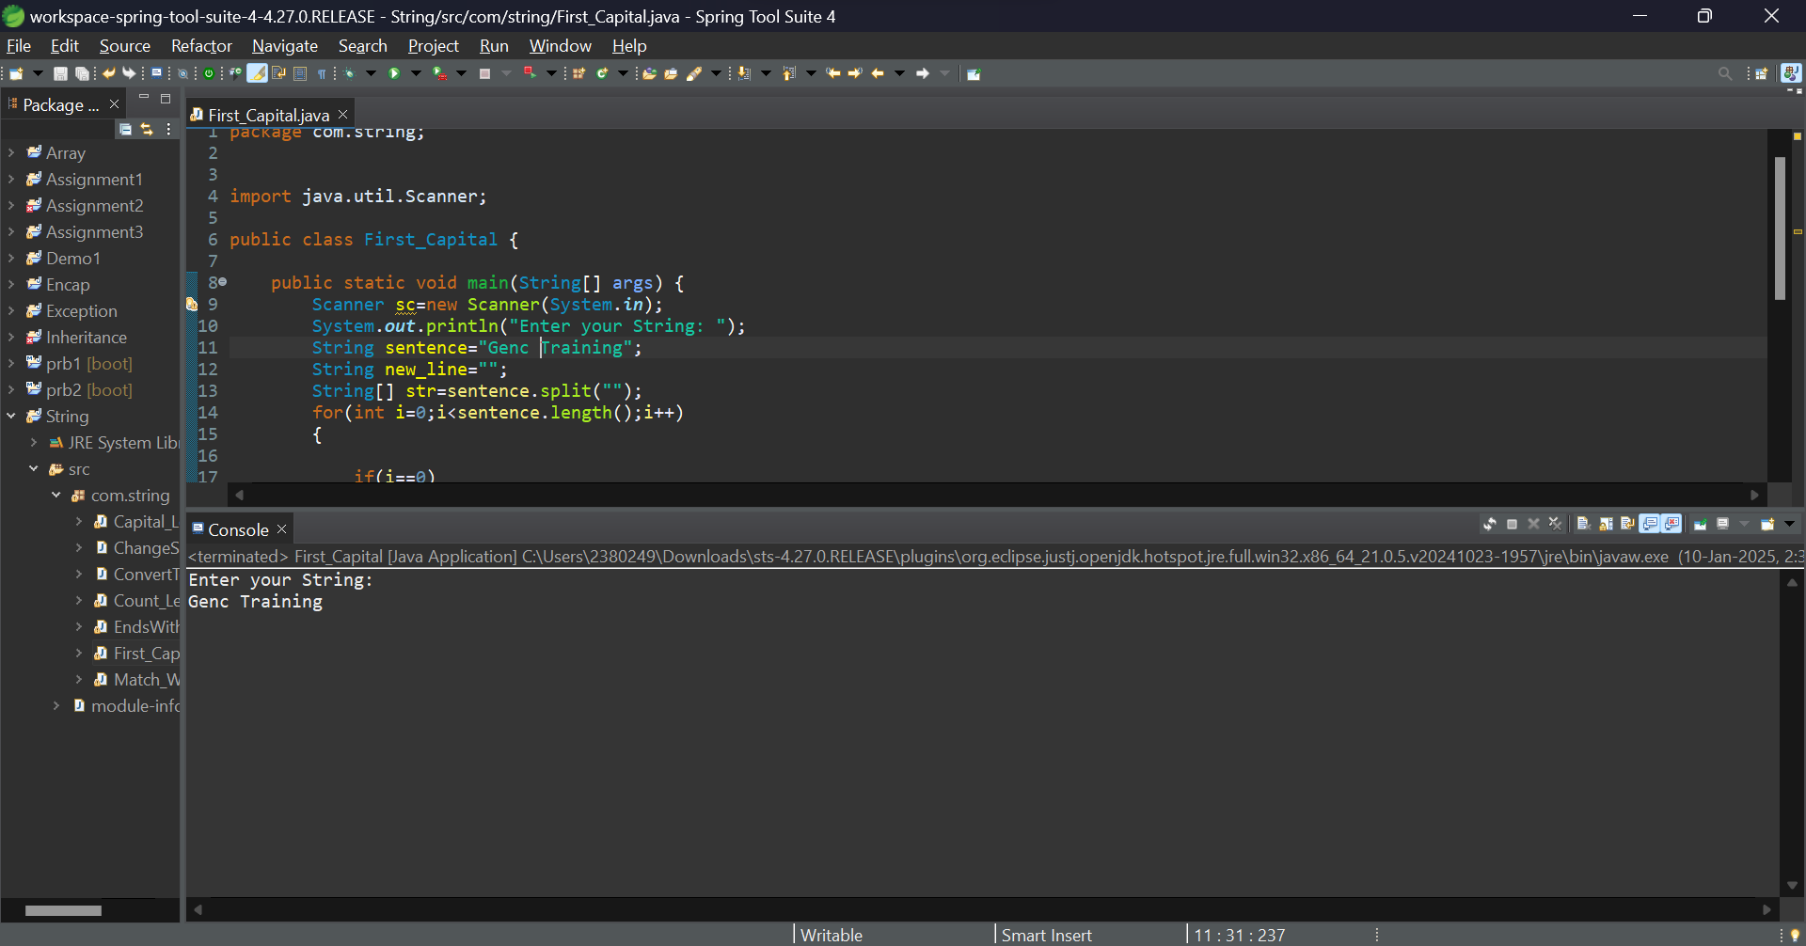

8) Convert the word from small letter to capital letter word in given String ?

String s =”b.v.raju college” //convert raju into capital.

Program:

package com.string;

import java.util.Scanner;

public class IndexOfString {

public static void main(String[] args) {

Scanner sc=new Scanner(System.***in***);

System.***out***.println("Enter your String: ");

String sentence=sc.nextLine();

System.***out***.println("Enter the index number to find the character:");

int index=sc.nextInt();

if(index<=sentence.length())

{

System.***out***.println("The index "+index+" is contain the character is: "+sentence.charAt(index));

}

else {

System.***out***.println("The index number is greater than length of the sentence.");

}

}

}

Output:

